Problem No: 04
Problem Name: Implement the Popular Image Enhancement Technique: Log Transformation & Power Log Transformation
Objective
- To understand the concept of image enhancement using intensity transformation techniques.
- To learn log transformation and power-law transformation methods.
- To implement log and power-law transformations using Python.
- To improve image visibility in dark and low-intensity regions.
- To gain practical experience in digital image processing.
Theory: Image enhancement techniques are used to improve the visual quality of digital images. Two important intensity transformation methods are Log Transformation and Power-Law (Gamma) Transformation.
1. Log Transformation
Log transformation is used to expand dark pixel values and compress higher intensity values. It is useful for enhancing details in dark regions of an image.
The mathematical formula is:
S=clog⁡(1+R)S
Where:
R = Original pixel value
S = Transformed pixel value
c = Constant scaling factor
2. Power-Law (Gamma) Transformation
Power-law transformation changes image intensity using a gamma value. It is commonly used for gamma correction in image displays.
The formula is:
S=cRγS
Where:
γ (gamma) controls brightness and contrast
If γ < 1, the image becomes brighter
If γ > 1, the image becomes darker
Code:
from PIL import Image
import matplotlib.pyplot as plt
import numpy as np

img = Image.open("sm_pic.jpg").convert("L")
img_array = np.array(img)
c = 255 / np.log(1 + np.max(img_array))
log_transformed = c * np.log(1 + img_array)
log_transformed = np.array(log_transformed, dtype=np.uint8)
gamma = 0.5
power_transformed = 255 * (img_array / 255) ** gamma

power_transformed = np.array(power_transformed, dtype=np.uint8)
plt.figure(figsize=(15,5))
plt.subplot(1,3,1)
plt.imshow(img, cmap='gray')
plt.title("Original Image")

plt.subplot(1,3,2)
plt.imshow(log_transformed, cmap='gray')
plt.title("Log Transformation")

plt.subplot(1,3,3)
plt.imshow(power_transformed, cmap='gray')
plt.title("Power-Law Transformation")

print("Log Transformed Image Matrix:\n")
print(log_transformed)

print("\nPower-Law Transformed Image Matrix:\n")
print(power_transformed)
plt.show()
Output:
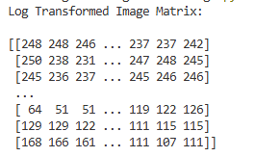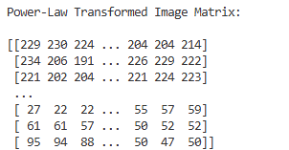
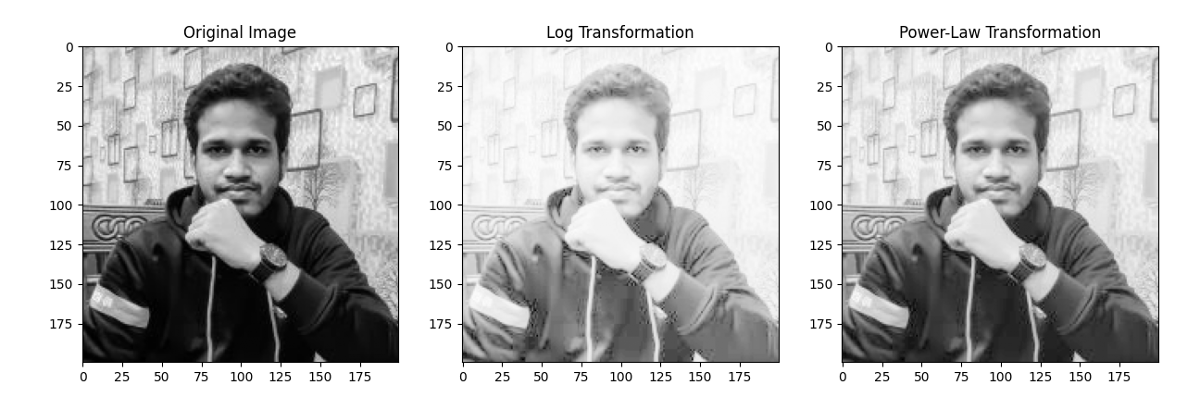
Result Discussion: The experiment successfully applied log transformation and power-law transformation to the image. Log transformation enhanced the dark regions by expanding lower intensity values, while power-law transformation adjusted brightness according to the gamma value.
The transformed images appeared clearer and more visually enhanced compared to the original image.

Analysis

Log transformation is effective for highlighting details in darker areas of an image. Power-law transformation provides flexible control over image brightness and contrast using gamma correction.

These transformations are widely used in image enhancement systems because they improve image quality and visibility without changing the image structure.

Opinion

This experiment helped in understanding important intensity transformation techniques used in digital image processing. It provided practical knowledge about enhancing image quality using mathematical transformations. The experiment is highly useful for applications in medical imaging, satellite imaging, and computer graphics.

